**Assignment -4** Python Programming

|  |  |
| --- | --- |
| Assignment Date | 31 October 2022 |
| Student Name | R.Jeyamary |
| Student Roll Number | 952819106011 |
| Maximum Marks | 2 Marks |

**Question-1:**

**Write code and connections in wokwi for ultrasonic sensor.**

|  |  |
| --- | --- |
| **Whenever distance is less than 100 cms send "alert" to ibm cloud and display in device** | |
| **recent events.** |  |

**Upload document with wokwi share link and images of ibm cloud**

**Solution:**

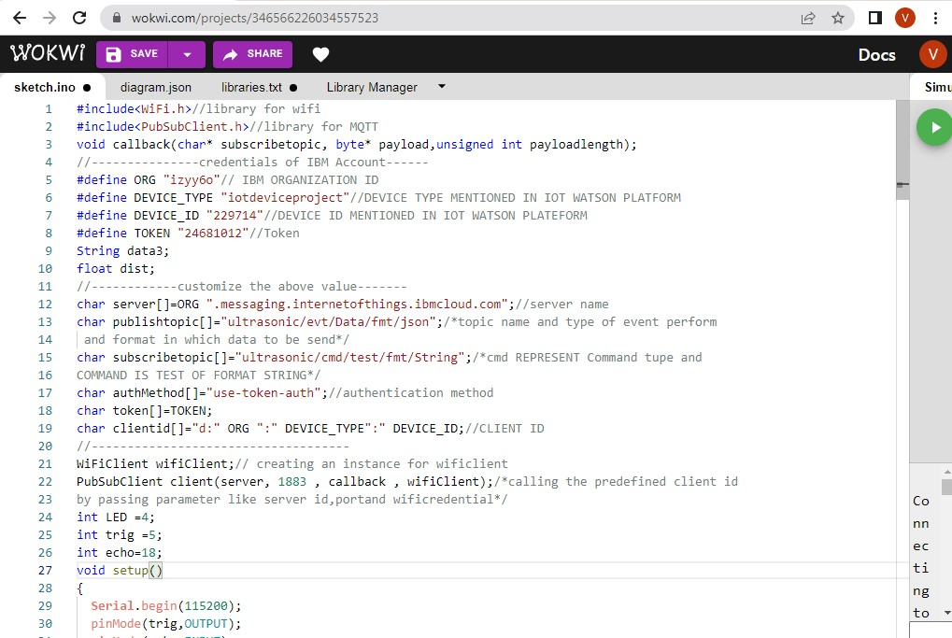

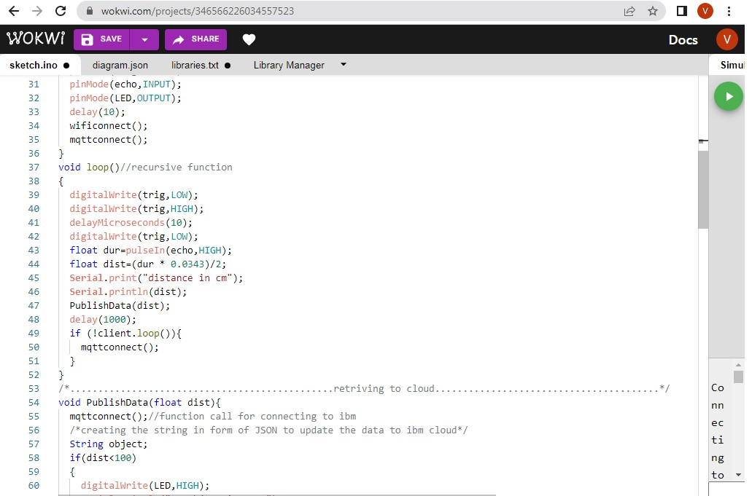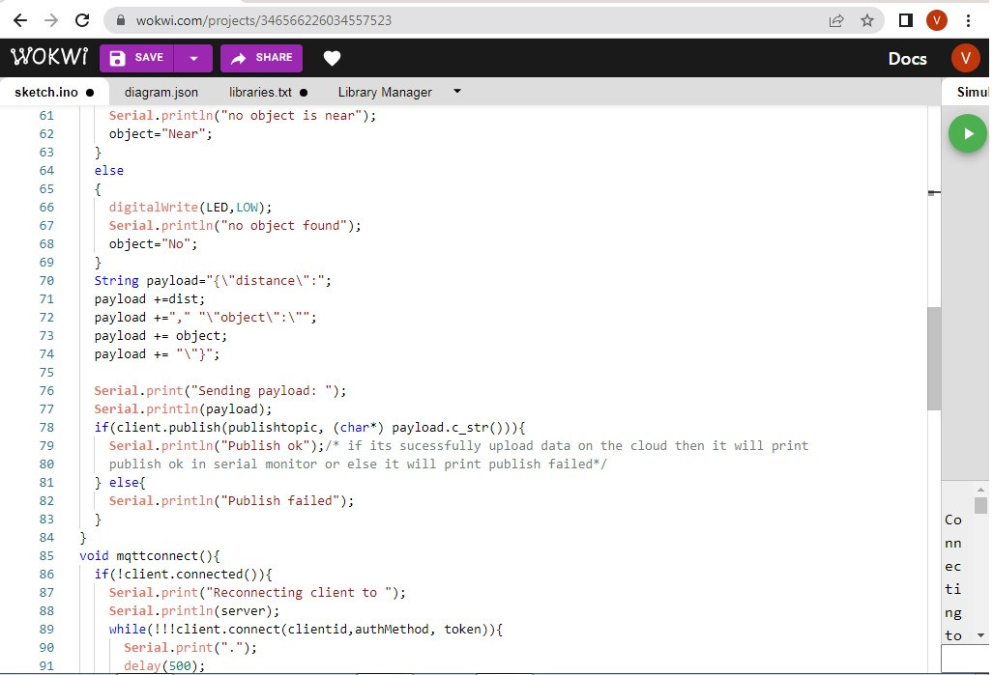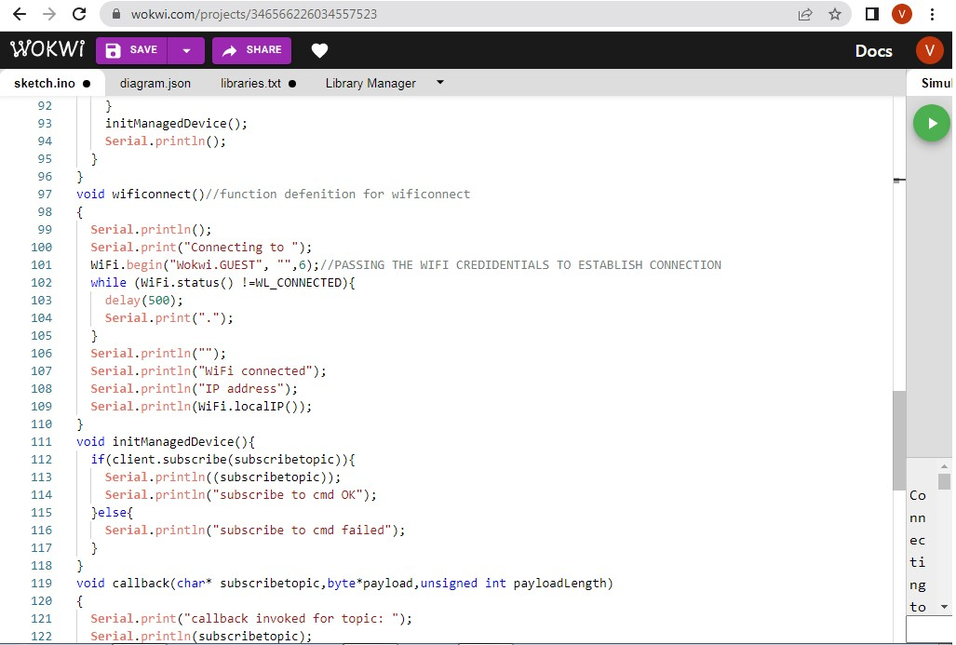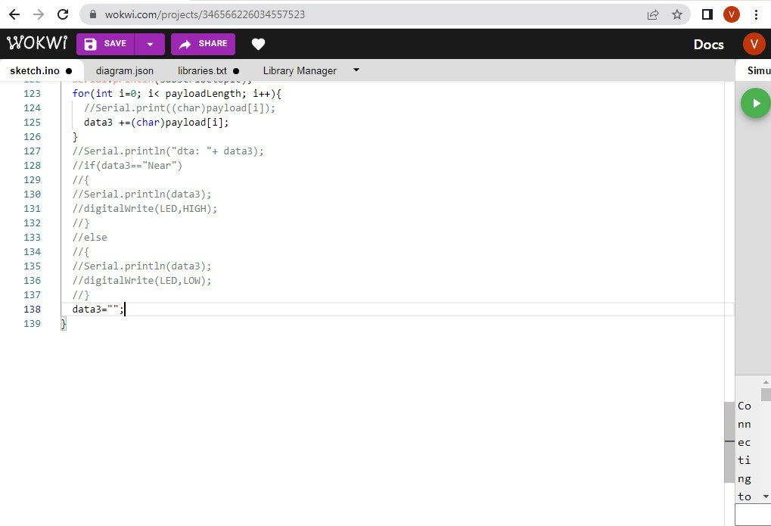

OUTPUT:

<https://wokwi.com/projects/346572482591851092>DATA SENT TO IBM CLOUD ON NO OBJECT DETECTED

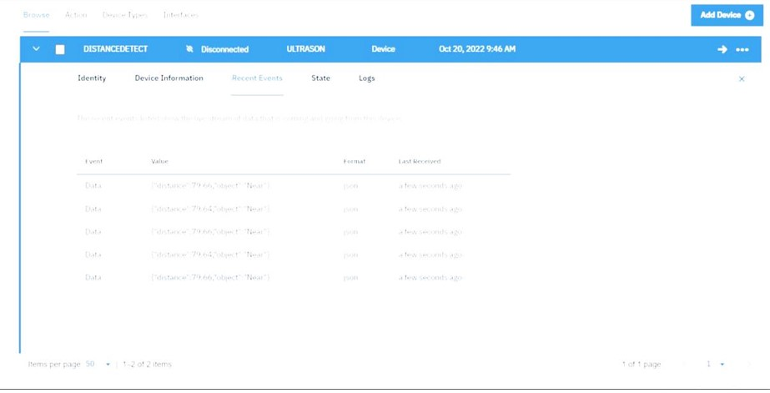

# WHEN NO OBJECT DETECTED BY ULTRASONIC DETECTOR

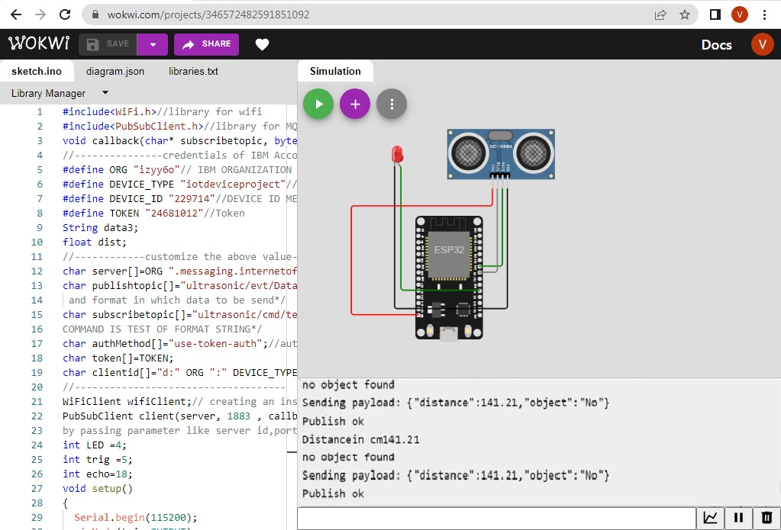

# DATA SENT TO IBM CLOUD ON OBJECT BEING DETECTED



# WHEN OBJECT DETECTED BY ULTRASONIC DETECTOR SENSOR

